

CAPSTONE PROJECT REPORT
Report 4 – Software Design Specification

– Hanoi, Jan 2025 –

Table of Contents
I. Record of Changes 3
II. Software Design Document 4
1. High Level Design 4
1.1 Software Architecture 4
1.2 Package Diagram 4
1.3 Database Design 5
2. Detailed Design 7
2.1 <Feature/Function Name1> 7
2.2 <Feature/Function Name2> 8
3. Class Specifications 8
3.1 package_name1 8
4. Other Design Specifications 9

I. Record of Changes
Date | A*  M, D | In charge | Change Description
02/07/2026 | A | HungPV | Added Section II.1.1 Software Architecture (high-level architecture diagram and component descriptions)
02/07/2026 | A | HungPV | Added Section II.1.2 Package Diagram (backend & frontend package diagrams, naming conventions, package descriptions)
02/07/2026 | A | HungPV | Added Section II.1.3 Database Design (ERD and detailed descriptions of all 16 tables)
02/07/2026 | A | HungPV | Added Section II.1.1 Software Architecture (high-level architecture diagram and component descriptions)
*A - Added M - Modified D - Deleted

II. Software Design Document

1. High-Level Design

1.1 Software Architecture
The Smart Warehouse Execution System (SWES) is designed as a layered, event-driven modular monolith. The system consists of a React single-page application (wes-client), a NestJS backend (wes) that owns all business logic, and a customized openTCS kernel (FMS) that executes physical routing and AGV control. The backend takes over the default openTCS dispatching: every transport order is pushed to the kernel with an already-assigned vehicle (intendedVehicle). Figure II-1 shows the overall architecture, the external systems, and the communication messages between the components.
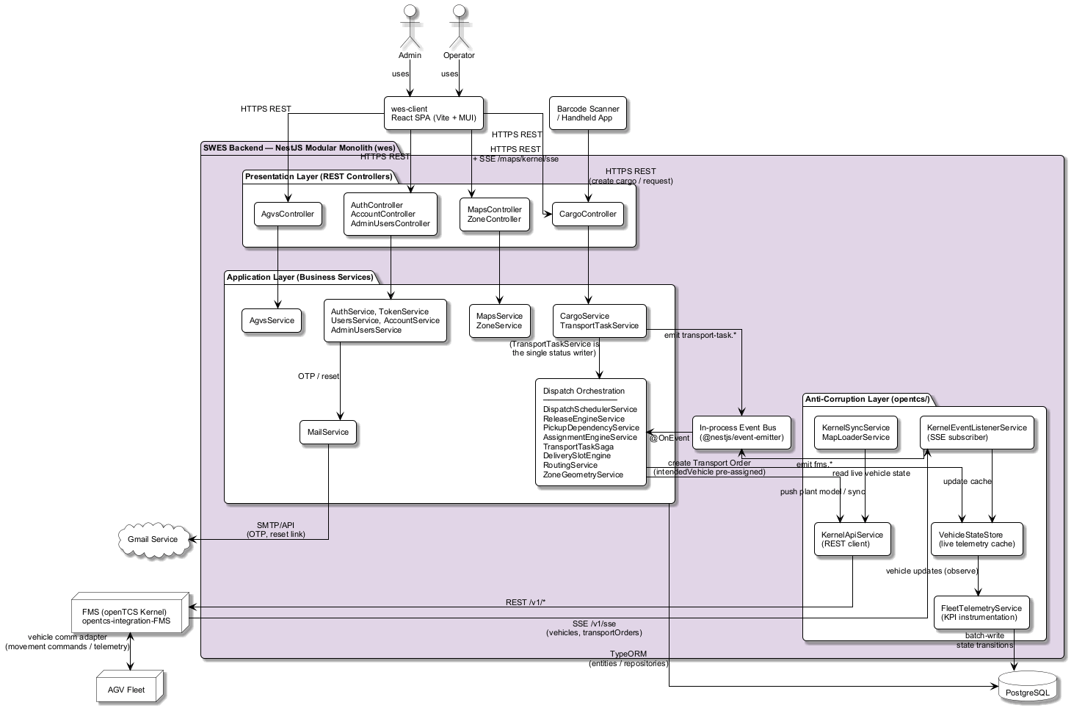
Figure II-1. SWES high-level software architecture
The responsibilities of each component in the diagram are described below:
No | Component | Description
01 | Admin / Operator | Human actors. The Admin configures the system (fleet, map/topology, users, dispatch policies) and monitors operations; the Operator creates and tracks transport requests. Both interact with the system through the wes-client web application.
02 | Barcode Scanner / Handheld App | On-site edge client. It optically decodes floor QR codes and package barcodes, then calls the SWES REST API to create a Cargo record and initiate the lifecycle of a Transport Request.
03 | wes-client (React SPA) | Single-page web application built with React, Vite and MUI. It renders data served by the backend over HTTPS REST and subscribes to the backend SSE endpoint (/maps/kernel/sse) for live AGV tracking on the warehouse map. It contains no business logic.
04 | Presentation Layer (REST Controllers) | NestJS controllers exposing the system API: AuthController/AccountController/AdminUsersController (authentication and user management), AgvsController (fleet registry), MapsController/ZoneController (map, topology and the SSE stream), CargoController (cargo and transport requests, also consumed by the barcode scanner). Controllers validate DTOs, enforce JWT/role guards and delegate to services.
05 | Application Layer (Business Services) | All business use cases. CargoService manages cargo records; TransportTaskService is the single write choke point for transport-task status (validate via state machine, persist, emit event). The Dispatch Orchestration group implements the core value of SWES: ReleaseEngineService with PickupDependencyService gates CREATED tasks (row-dependency anti-congestion rule, BLOCKED state), AssignmentEngineService selects the nearest eligible AGV (Dijkstra over the plant-model road graph via RoutingService), TransportTaskSaga advances the three-leg order flow (pick-up, approach, drop-off), DeliverySlotEngine late-binds the concrete drop-off slot, and DispatchSchedulerService debounces and triggers release/assignment cycles. Supporting services: AgvsService, MapsService/ZoneService, AuthService/TokenService/UsersService/AccountService/AdminUsersService, MailService.
06 | In-process Event Bus (@nestjs/event-emitter) | Decouples producers and consumers inside the monolith. TransportTaskService emits transport-task.* events; the openTCS listener emits fms.* events; engines react via @OnEvent handlers. No external message broker is used.
07 | Anti-Corruption Layer (opentcs/) | The only place that talks to openTCS. KernelApiService wraps the kernel REST API (transport orders, plant model, vehicles); KernelEventListenerService subscribes to the kernel SSE stream and translates telemetry frames into fms.* domain events; VehicleStateStore caches live vehicle telemetry in memory; KernelSyncService and MapLoaderService push/synchronize the plant model at startup. openTCS types never leak into business modules.
08 | PostgreSQL | Relational database accessed through TypeORM entities/repositories. Stores AGVs, cargos, transport requests, maps, zones, points/paths, users and the append-only event log.
09 | FMS (openTCS Kernel) | External fleet-management middleware (customized openTCS, project opentcs-integration-FMS). It receives transport orders whose vehicle has already been chosen by SWES, performs pathfinding and physical vehicle control, and continuously publishes vehicle and transport-order telemetry to SWES over SSE (/v1/sse).
10 | AGV Fleet | The physical automated guided vehicles. They communicate only with the openTCS kernel through its vehicle communication adapters (movement commands and telemetry).
11 | Gmail Service | Third-party email delivery service used by MailService to send authentication emails: OTP codes and password-reset links.

1.2 Package Diagram
The SWES software is organized into two sub-systems: the NestJS backend (wes) and the React single-page application (wes-client). Figure II-2 shows the package structure of the backend and Figure II-3 shows the frontend; in both diagrams the dependency arrows are derived from the actual import relationships in the source code (solid arrow = module dependency, dashed arrow = entity/type reuse).
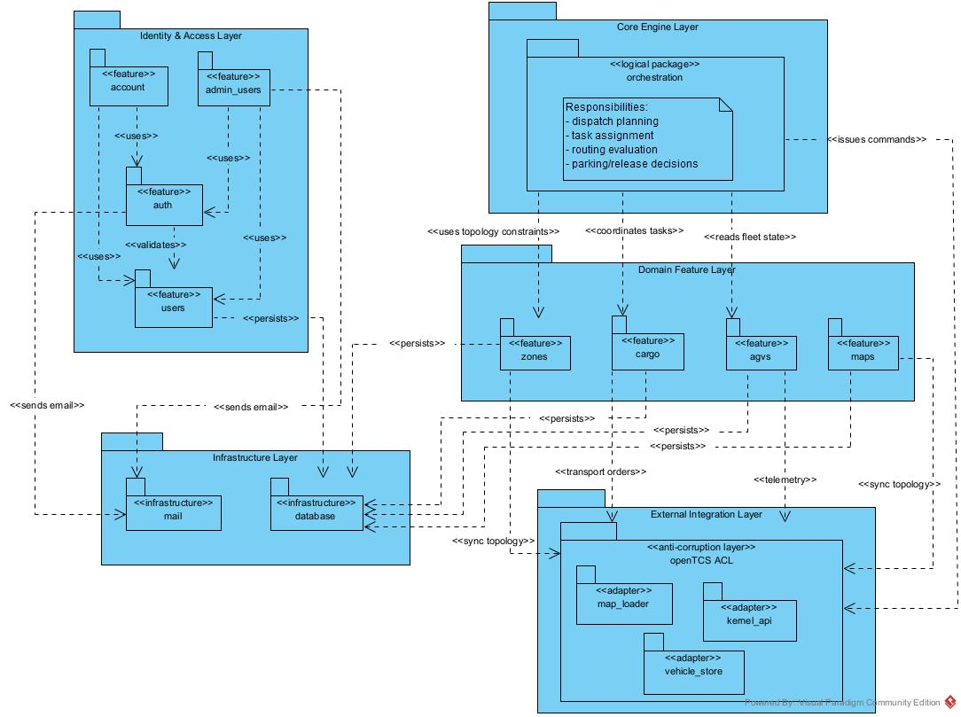
Figure II-2. Package diagram — wes backend (NestJS)
In the backend, every business package that needs the fleet-management kernel (agvs, cargo, maps) depends only on the opentcs package — the Anti-Corruption Layer — so no openTCS type or HTTP call leaks into business code. The cargo package is the core domain: it contains the dispatch orchestration services, a framework-free domain sub-package (state machine, dispatch and row-dependency policies, domain events) and its persistence entities. The user-management cluster (auth, account, admin_users) depends on the shared users package and on mail for OTP and password-reset delivery. The database package holds TypeORM configuration and migrations and is imported once at application bootstrap.
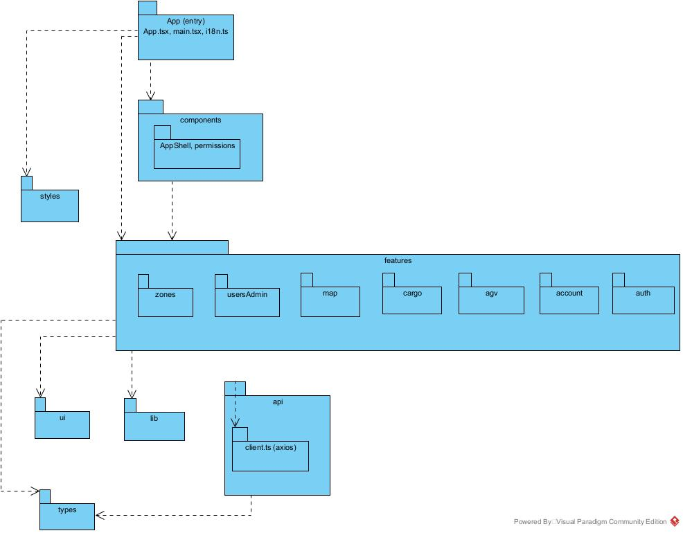
Figure II-3. Package diagram — wes-client (React SPA)
In the frontend, each business feature lives in its own folder under features (auth, account, agv, cargo, map, usersAdmin, zones). Features fetch server state exclusively through the api package — one file per domain sharing a single axios instance (client.ts) — and render with the shared ui controls and MUI. Response/request types are centralized in types. No business logic exists in the frontend; it renders data served by the backend.
Naming conventions. Backend: each module is a kebab-case folder under src/ whose files are named by role — {module}.controller.ts, {module}.service.ts, {module}.module.ts, {module}.dto.ts, entities/{entity}.entity.ts — and pure business rules live in domain/ with no framework import. Classes are PascalCase with a role suffix (Controller, Service, Engine, Saga, Store). Domain events are named {entity-kebab-case}.{past-tense-verb}, e.g. transport-task.status-changed. Frontend: feature folders are camelCase under features/; API modules are api/{domain}.ts; shared types are types/{domain}.ts; hooks are prefixed use*.
Package descriptions — wes backend (NestJS):

No | Package | Description
01 | auth | JWT authentication: login, token refresh, OTP verification, password reset; provides the auth guards and role-based access control used by all controllers.
02 | account | Self-service account use cases for the signed-in user (view/update profile, change password).
03 | users | Shared user domain: user, role, session, refresh-token, password-reset, and preference entities with their queries; consumed by auth, account, and admin_users.
04 | admin_users | Administrator use cases for managing user accounts (create, update, assign roles, activate/deactivate).
05 | agvs | AGV fleet registry: AGV profile and configuration, dispatch enable/ignore flags, battery thresholds.
06 | cargo | Core business domain: cargo records, transport tasks and the dispatch orchestration engines (release, pickup-dependency, assignment, saga, delivery-slot, routing, zone-geometry). domain/ holds framework-free rules (state machine, dispatch and row-dependency policies, events); entities/ holds persistence models.
07 | maps | Warehouse map management: QR-grid map records, plant-model access, and the SSE endpoint streaming live kernel state to the client.
08 | zones | Warehouse topology: zones and zone members (storage slots and their geometry).
09 | opentcs | Anti-Corruption Layer to the openTCS kernel: REST client (KernelApiService), SSE listener translating telemetry into fms.* events, in-memory vehicle-state cache, fleet telemetry instrumentation and plant-model loader (map_loader).
10 | mail | Outbound email delivery (OTP codes, password-reset links) via the Gmail service.
11 | database | TypeORM datasource configuration, migrations and seeding.

Package descriptions — wes-client (React SPA):
No | Package | Description
01 | App (entry) | Application bootstrap: App.tsx routing, main.tsx mount, i18n dictionary, global providers (react-query, theme).
02 | components | Cross-feature UI: AppShell layout (navigation, top bar) and route permission mapping.
03 | features | One folder per business feature (auth, account, agv, cargo, map, usersAdmin, zones): pages, feature hooks and feature-specific components; the map feature renders the live warehouse canvas with react-konva.
04 | api | REST client layer: one file per domain wrapping the backend API; client.ts holds the shared axios instance with authentication interceptors.
05 | types | TypeScript request/response types per domain.
06 | ui | Reusable presentational controls (form fields, dialogs, toasts, icons, overlays).
07 | lib | Small utilities: formatting helpers and react-query helpers.
08 | styles | Global styles and theme.

1.3 Database Design
The SWES database is a single PostgreSQL schema managed by TypeORM migrations. It contains 16 tables in four clusters: user & authentication (users, roles, user_roles, refresh_tokens, user_sessions, password_reset_tokens, user_preferences), AGV fleet (agvs), warehouse topology (zones, zone_members, map_records) and core business with its instrumentation (cargos, transport_requests, task_status_transitions, sse_sessions, vehicle_state_transitions). The map topology itself (points, paths, locations) is intentionally NOT stored in the WES database — it lives in the openTCS plant model and is accessed through the Anti-Corruption Layer. Figure II-4 shows the table relationships; solid keys are enforced foreign-key constraints, the remaining *_id columns are semantic references resolved at the application level.
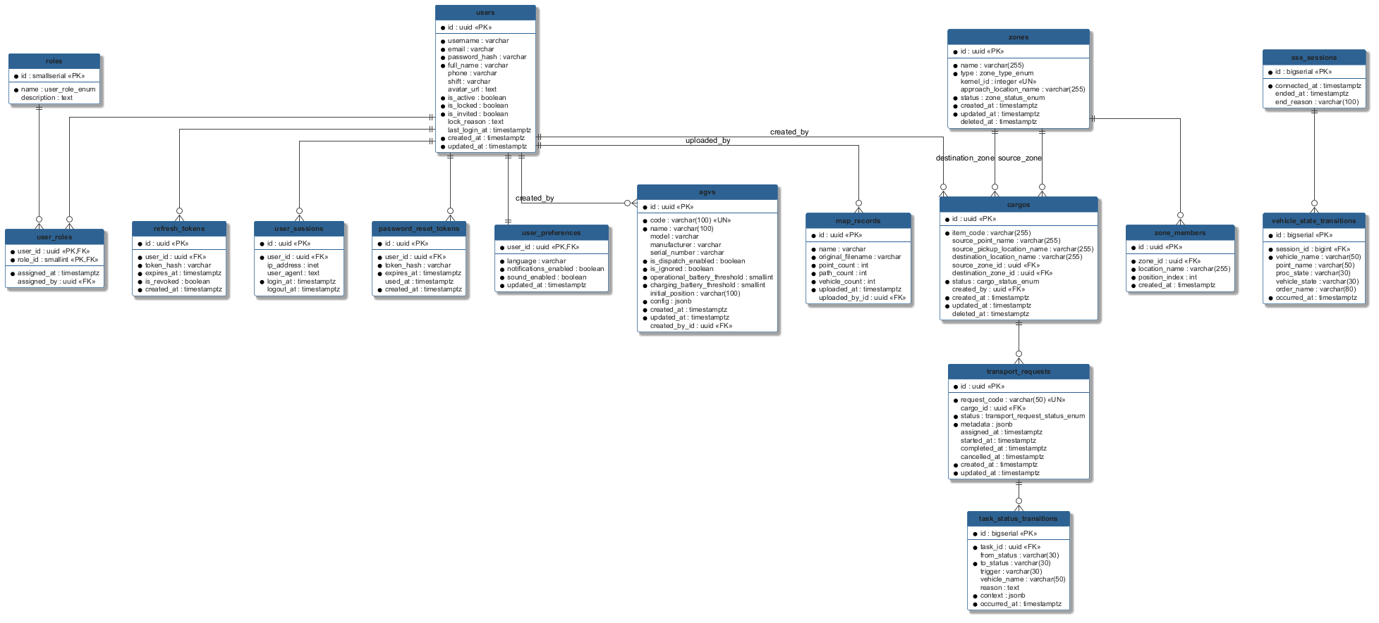
Figure II-4. SWES entity relationship diagram (generated from the TypeORM entities)
* PK ~ Primary Key; FK ~ Foreign Key (including application-level references); UN ~ Unique; NN ~ Not Null

1.3.1 users
System user accounts with profile details and authentication/status flags.
No | Field | PK | FK | UN | NN | Description
01 | id | x |  |  | x | Primary key (UUID).
02 | username |  |  |  | x | Login name of the user.
03 | email |  |  |  | x | Email address used for OTP and password-reset delivery.
04 | password_hash |  |  |  | x | Bcrypt hash of the password; never stores plain text.
05 | full_name |  |  |  | x | Display name.
06 | phone |  |  |  |  | Contact phone number.
07 | shift |  |  |  |  | Working shift of the operator.
08 | avatar_url |  |  |  |  | Profile picture URL.
09 | is_active |  |  |  | x | Account enabled flag (default true).
10 | is_locked |  |  |  | x | Account locked by admin (default false).
11 | is_invited |  |  |  | x | Invitation-pending flag (default false).
12 | lock_reason |  |  |  |  | Reason the account was locked.
13 | last_login_at |  |  |  |  | Timestamp of the most recent login.
14 | created_at |  |  |  | x | Row creation time.
15 | updated_at |  |  |  | x | Last modification time.

1.3.2 roles
Authorization roles that determine permissions (ADMIN, OPERATOR).
No | Field | PK | FK | UN | NN | Description
01 | id | x |  |  | x | Primary key (small serial).
02 | name |  |  |  | x | Role name enum: ADMIN | OPERATOR.
03 | description |  |  |  |  | Human-readable description of the role.

1.3.3 user_roles
Many-to-many mapping assigning roles to users.
No | Field | PK | FK | UN | NN | Description
01 | user_id | x | x |  | x | Composite PK; references users.id (ON DELETE CASCADE).
02 | role_id | x | x |  | x | Composite PK; references roles.id.
03 | assigned_at |  |  |  | x | When the role was granted (default now()).
04 | assigned_by |  | x |  |  | Admin user who granted the role.

1.3.4 refresh_tokens
Refresh tokens keeping authentication sessions alive securely.
No | Field | PK | FK | UN | NN | Description
01 | id | x |  |  | x | Primary key (UUID).
02 | user_id |  | x |  | x | Owner of the token.
03 | token_hash |  |  |  | x | Hash of the refresh token; raw token is never stored.
04 | expires_at |  |  |  | x | Expiry timestamp.
05 | is_revoked |  |  |  | x | Set true on logout/rotation (default false).
06 | created_at |  |  |  | x | Row creation time.

1.3.5 user_sessions
Login/logout audit trail with client information.
No | Field | PK | FK | UN | NN | Description
01 | id | x |  |  | x | Primary key (UUID).
02 | user_id |  | x |  | x | User who logged in.
03 | ip_address |  |  |  |  | Client IP address (inet).
04 | user_agent |  |  |  |  | Client browser/device string.
05 | login_at |  |  |  | x | Login time (default now()).
06 | logout_at |  |  |  |  | Logout time; NULL while the session is open.

1.3.6 password_reset_tokens
Single-use tokens generated for password reset requests.
No | Field | PK | FK | UN | NN | Description
01 | id | x |  |  | x | Primary key (UUID).
02 | user_id |  | x |  | x | User requesting the reset.
03 | token_hash |  |  |  | x | Hash of the reset token.
04 | expires_at |  |  |  | x | Expiry timestamp.
05 | used_at |  |  |  |  | Set when consumed; enforces single use.
06 | created_at |  |  |  | x | Row creation time.

1.3.7 user_preferences
Per-user UI preferences.
No | Field | PK | FK | UN | NN | Description
01 | user_id | x | x |  | x | PK and reference to users.id (one-to-one).
02 | language |  |  |  | x | UI language (default 'vi').
03 | notifications_enabled |  |  |  | x | Notification toggle (default true).
04 | sound_enabled |  |  |  | x | Sound toggle (default false).
05 | updated_at |  |  |  | x | Last modification time.

1.3.8 agvs
AGV fleet registry: configuration and dispatch eligibility of each vehicle.
No | Field | PK | FK | UN | NN | Description
01 | id | x |  |  | x | Primary key (UUID).
02 | code |  |  | x | x | Unique vehicle code; MUST equal the openTCS vehicle name (join key with FMS telemetry).
03 | name |  |  |  | x | Display name.
04 | model |  |  |  |  | Vehicle model.
05 | manufacturer |  |  |  |  | Vehicle manufacturer.
06 | serial_number |  |  |  |  | Hardware serial number.
07 | is_dispatch_enabled |  |  |  | x | Eligibility gate for the assignment engine (default true).
08 | is_ignored |  |  |  | x | Excluded from dispatch entirely when true (default false).
09 | operational_battery_threshold |  |  |  | x | Minimum battery % for normal dispatch (default 20).
10 | charging_battery_threshold |  |  |  | x | Battery % that forces a charging order (default 10).
11 | initial_position |  |  |  |  | Point name where the vehicle starts.
12 | config |  |  |  | x | Free-form JSONB configuration (default {}).
13 | created_at |  |  |  | x | Row creation time.
14 | updated_at |  |  |  | x | Last modification time.
15 | created_by_id |  | x |  |  | Admin who registered the AGV.

1.3.9 zones
Warehouse zones (pickup rows/drop-off areas) used by dispatch orchestration.
No | Field | PK | FK | UN | NN | Description
01 | id | x |  |  | x | Primary key (UUID).
02 | name |  |  |  | x | Zone display name.
03 | type |  |  |  | x | Enum: PICKUP | DROPOFF.
04 | kernel_id |  |  | x |  | Sequential ID used to name openTCS locations; NULL for PICKUP zones.
05 | approach_location_name |  |  |  |  | openTCS location of the zone's approach point (TO2 target).
06 | status |  |  |  | x | Enum: ACTIVE | STALE (default ACTIVE).
07 | created_at |  |  |  | x | Row creation time.
08 | updated_at |  |  |  | x | Last modification time.
09 | deleted_at |  |  |  |  | Soft-delete timestamp.

1.3.10 zone_members
Member slots of a zone with their ordering along the lane.
No | Field | PK | FK | UN | NN | Description
01 | id | x |  |  | x | Primary key (UUID).
02 | zone_id |  | x |  | x | Owning zone (ON DELETE CASCADE).
03 | location_name |  |  |  | x | openTCS location name of the slot.
04 | position_index |  |  |  | x | Order along the lane; drives row-dependency and fill order.
05 | created_at |  |  |  | x | Row creation time.

1.3.11 map_records
Uploaded plant-model (QR-grid map) files and their statistics.
No | Field | PK | FK | UN | NN | Description
01 | id | x |  |  | x | Primary key (UUID).
02 | name |  |  |  | x | Map display name.
03 | original_filename |  |  |  | x | Uploaded file name.
04 | point_count |  |  |  | x | Number of points parsed from the model (default 0).
05 | path_count |  |  |  | x | Number of paths parsed (default 0).
06 | vehicle_count |  |  |  | x | Number of vehicles in the model (default 0).
07 | uploaded_at |  |  |  | x | Upload time.
08 | uploaded_by_id |  | x |  |  | Admin who uploaded the map.

1.3.12 cargos
Physical goods units registered by the barcode scanner or operator.
No | Field | PK | FK | UN | NN | Description
01 | id | x |  |  | x | Primary key (UUID).
02 | item_code |  |  |  | x | Scanned barcode of the goods.
03 | source_point_name |  |  |  |  | Point where the cargo currently sits (from floor QR).
04 | source_pickup_location_name |  |  |  |  | openTCS pickup location linked to the source point.
05 | destination_location_name |  |  |  |  | Concrete drop-off slot; NULL until committed at the TO2 barrier (late binding).
06 | source_zone_id |  | x |  |  | Zone the cargo is picked from.
07 | destination_zone_id |  | x |  |  | Reserved drop-off zone (capacity-checked at creation).
08 | status |  |  |  | x | Enum: ACTIVE | DELIVERED | CANCELLED (default ACTIVE).
09 | created_by |  | x |  |  | User/scanner account that registered the cargo.
10 | created_at |  |  |  | x | Row creation time.
11 | updated_at |  |  |  | x | Last modification time.
12 | deleted_at |  |  |  |  | Soft-delete timestamp.

1.3.13 transport_requests
Transport tasks and their lifecycle; one cargo may have several tasks over time.
No | Field | PK | FK | UN | NN | Description
01 | id | x |  |  | x | Primary key (UUID).
02 | request_code |  |  | x | x | Human-readable unique request code.
03 | cargo_id |  | x |  |  | Cargo being transported.
04 | status |  |  |  | x | Enum: CREATED | READY_TO_ASSIGN | BLOCKED | PICKING_UP | DELIVERING | DELIVERY_COMPLETED | CANCELLED | FAILED.
05 | metadata |  |  |  | x | JSONB: assignedVehicleName, to1Name/to2Name/to3Name, approachLocationName, blockedReason.
06 | assigned_at |  |  |  |  | When a vehicle was assigned.
07 | started_at |  |  |  |  | When execution started.
08 | completed_at |  |  |  |  | When delivery completed.
09 | cancelled_at |  |  |  |  | When the task was cancelled.
10 | created_at |  |  |  | x | Row creation time.
11 | updated_at |  |  |  | x | Last modification time.

1.3.14 task_status_transitions
Insert-only audit of every task status change, written exclusively by TransportTaskService.
No | Field | PK | FK | UN | NN | Description
01 | id | x |  |  | x | Primary key (bigserial).
02 | task_id |  | x |  | x | Transport task that changed.
03 | from_status |  |  |  |  | Previous status; NULL only on the birth row.
04 | to_status |  |  |  | x | New status.
05 | trigger |  |  |  |  | Cause of the change: API | RELEASE_ENGINE | ASSIGNMENT_ENGINE | SAGA.
06 | vehicle_name |  |  |  |  | Snapshot of the assigned vehicle at transition time.
07 | reason |  |  |  |  | Free-text reason (e.g. blocked reason).
08 | context |  |  |  | x | JSONB measurements (e.g. distanceToSource at assign).
09 | occurred_at |  |  |  | x | Transition time (default now()).

1.3.15 sse_sessions
One row per kernel SSE (re)connect, bracketing telemetry so analysis never spans a reconnect gap.
No | Field | PK | FK | UN | NN | Description
01 | id | x |  |  | x | Primary key (bigserial).
02 | connected_at |  |  |  | x | SSE connect time (default now()).
03 | ended_at |  |  |  |  | SSE disconnect time; NULL while open.
04 | end_reason |  |  |  |  | Why the session ended (error, shutdown, ...).

1.3.16 vehicle_state_transitions
Insert-only log of observed vehicle state changes, batch-written by FleetTelemetryService for KPI evaluation.
No | Field | PK | FK | UN | NN | Description
01 | id | x |  |  | x | Primary key (bigserial).
02 | session_id |  | x |  | x | SSE session the observation belongs to.
03 | vehicle_name |  |  |  | x | openTCS vehicle name.
04 | point_name |  |  |  |  | Current point; NULL while between points.
05 | proc_state |  |  |  |  | Kernel processing state (IDLE, PROCESSING_ORDER, ...).
06 | vehicle_state |  |  |  |  | Kernel vehicle state (IDLE, EXECUTING, CHARGING, ...).
07 | order_name |  |  |  |  | Transport order being executed.
08 | occurred_at |  |  |  | x | Observation time (kernel-side when available).

2. Detailed Design

2.1 Transport Request Intake & Row‑Dependency Release
Creating a cargo record atomically reserves a drop‑off seat, births a CREATED transport task, and pokes the dispatcher. The Release Engine then applies the anti‑congestion row‑dependency rule (WF‑02): a cargo standing behind an un‑picked cargo in the same lane is held BLOCKED until the one in front leaves its source point.

2.1.1 Class Diagram

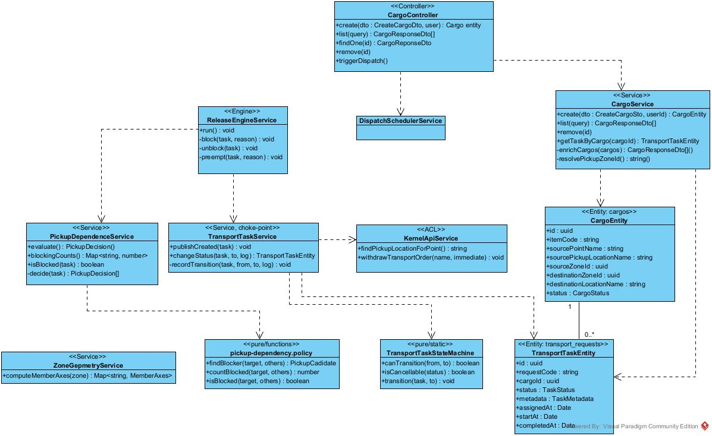
Figure II‑2.1.1 - Class diagram: cargo intake, release engine, and the shared write choke point.

2.1.2 Sequence Diagram - Create Cargo & publish transport task
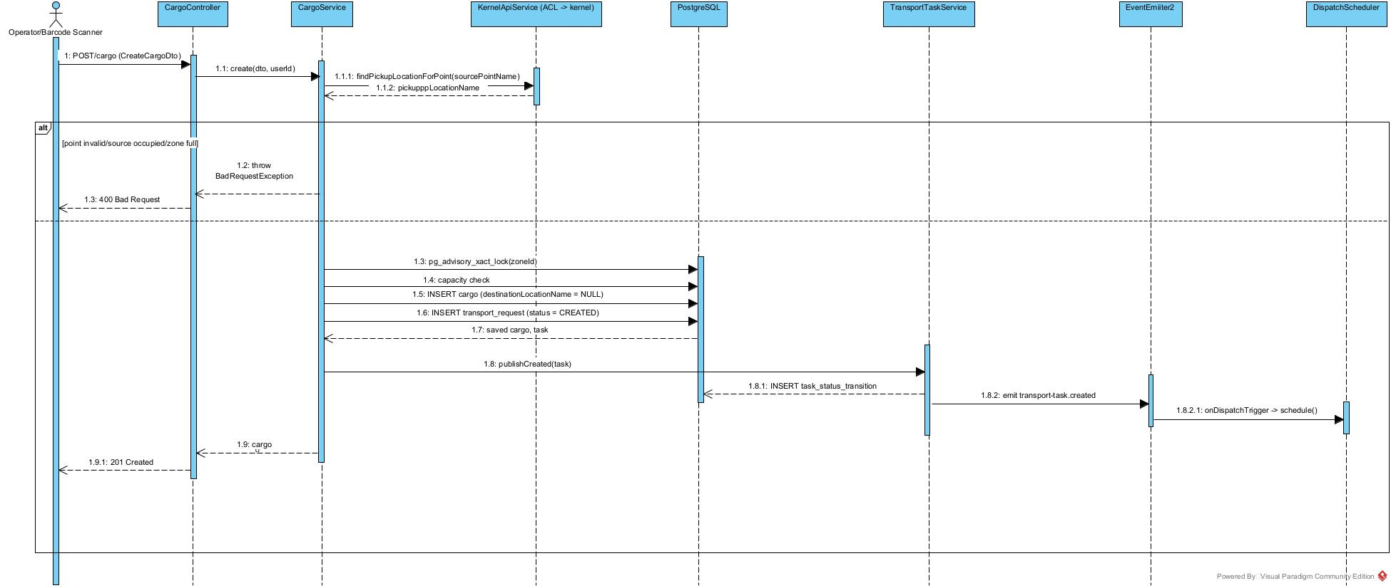
Figure II‑2.1.2 - Create cargo: seat reservation, task birth, and dispatch trigger.

2.1.3 Sequence Diagram - Release Engine: release / block / preempt
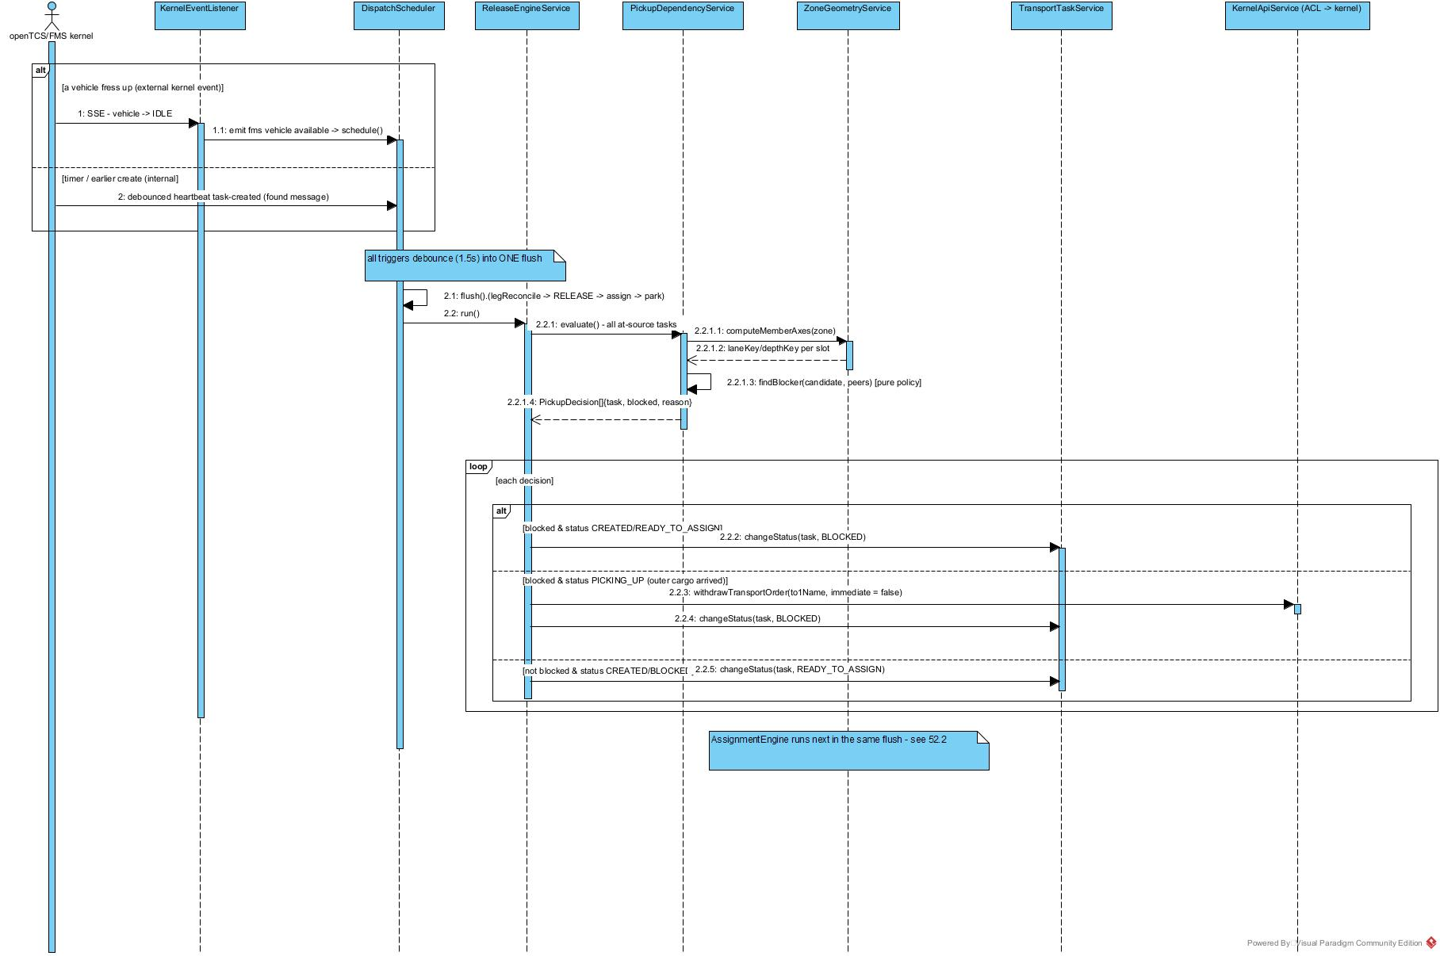
Figure II‑2.1.3 - Release Engine: release/block/preempt.

2.2 AGV Assignment - Weighted Dispatch (Hungarian / Greedy + Lookahead)
The assignment engine turns READY_TO_ASSIGN tasks into PICKING_UP by solving a global minimum‑cost matching over a task×vehicle cost matrix. Base cost is the directed road‑graph shortest‑path distance vehicle to pickup (Dijkstra on the reverse graph), optionally scaled per vehicle by a battery term.

2.2.1 Class Diagram
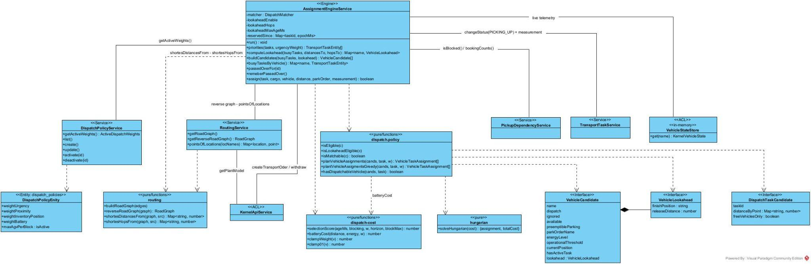
Figure II‑2.2.1 - Class diagram: xxxx.

2.2.2 Sequence Diagram - Assignment run (selection -> matching -> dispatch)
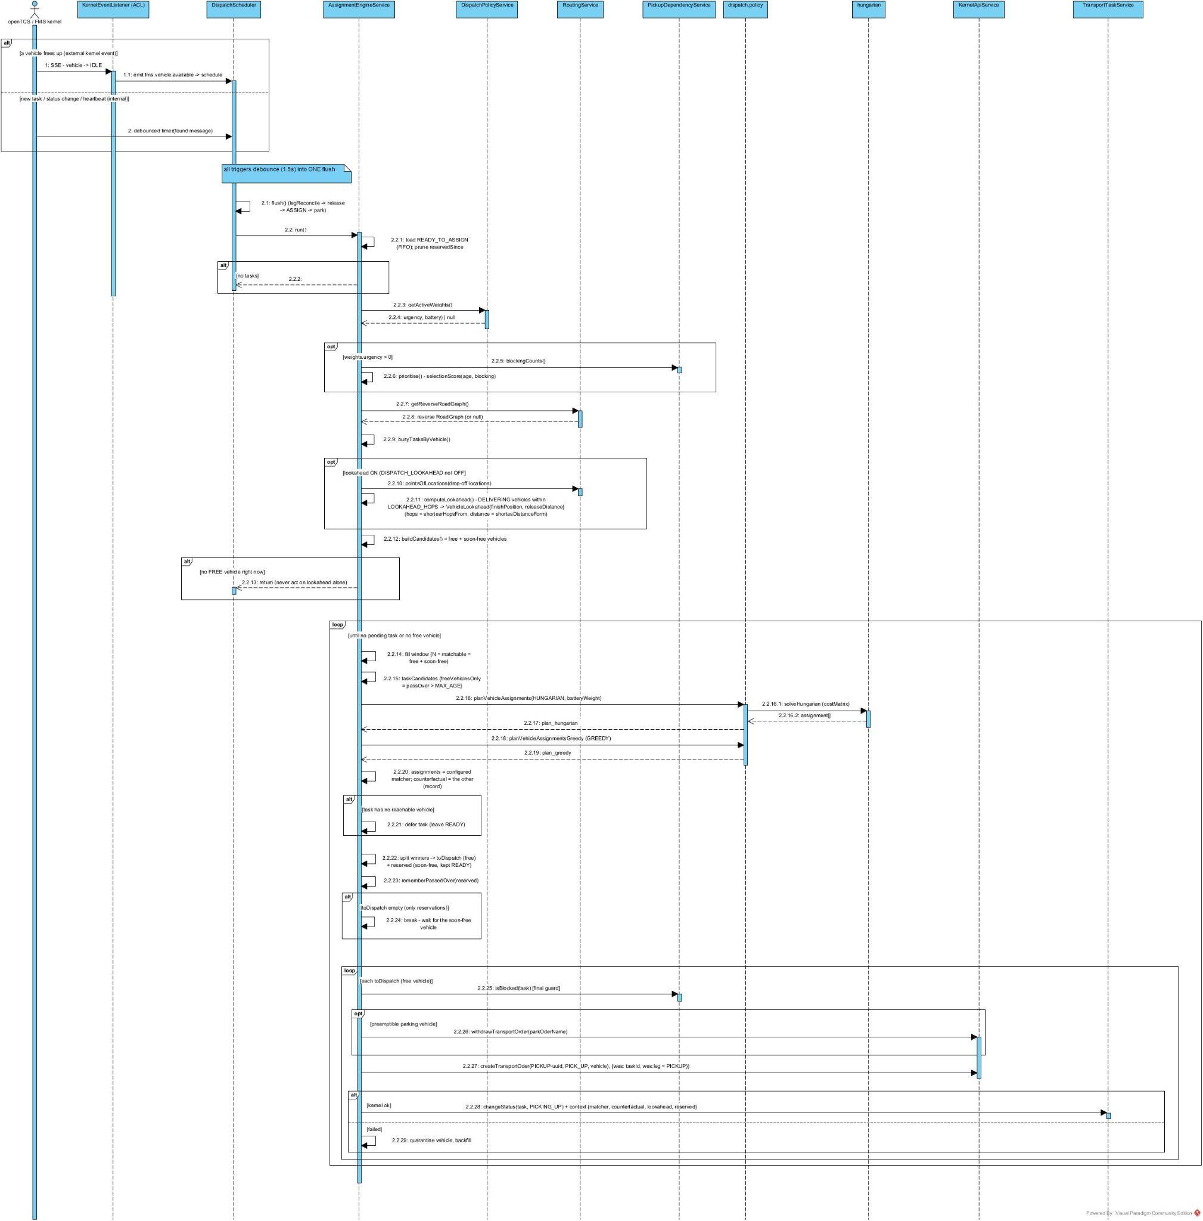
Figure II‑2.2.2 - xxxx.

2.3 Multi‑Leg Transport Order Execution (Saga)
TransportTaskSaga is a process manager reacting to fms.transport-order.finished. It advances each task through three openTCS orders - TO1 (PICK_UP) -> TO2 (approach, a MOVE NOP to the drop‑off zone's feeder head) -> TO3 (DROP_OFF) - committing the concrete drop‑off slot late, at the TO2 barrier, under a per‑zone advisory lock so fill order stays correct on one‑way lanes.

2.3.1 Class Diagram
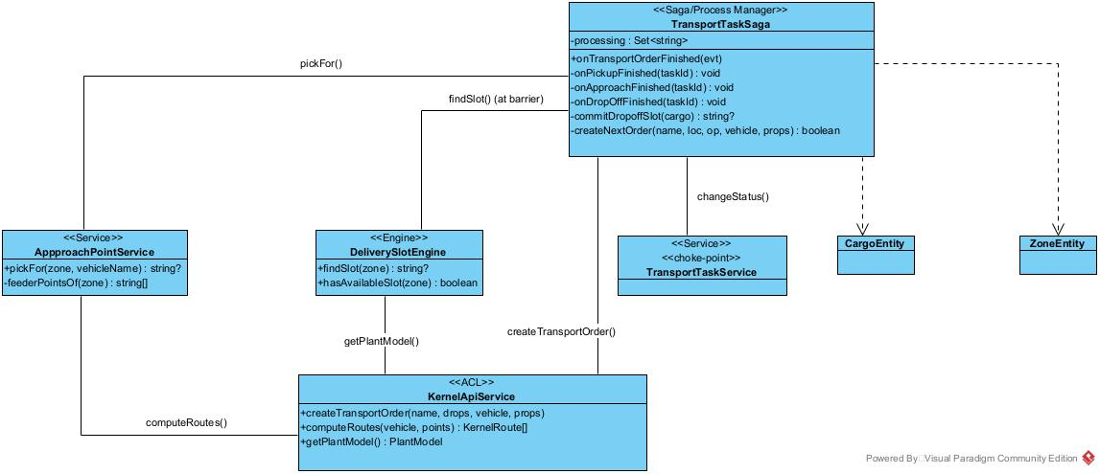

2.3.2 Sequence Diagram - Leg progression
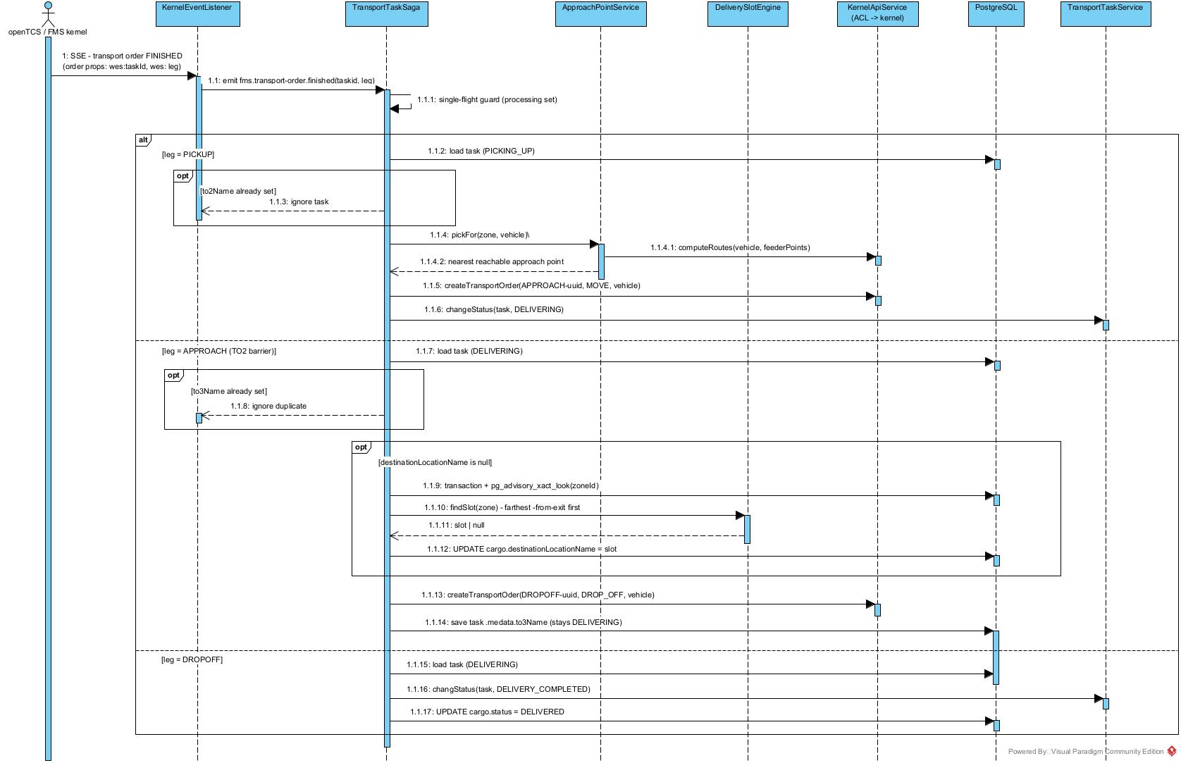

2.4 Idle Parking & Preemption

2.4.1 Class Diagram
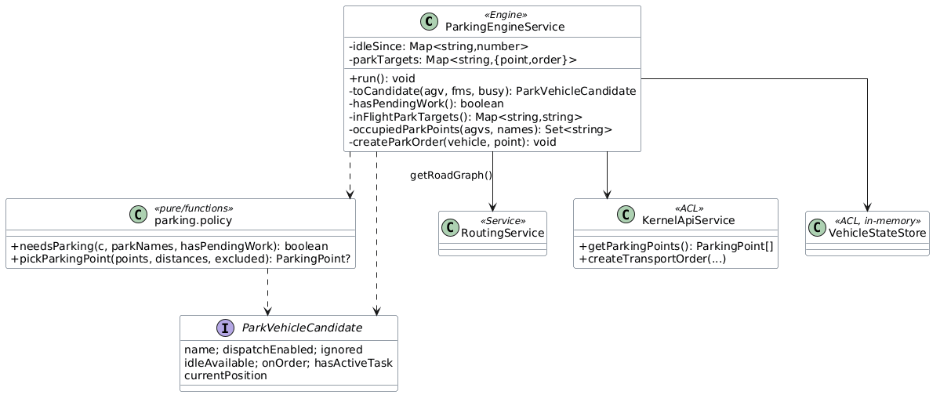

2.4.2 Sequence Diagram - Park an idle vehicle

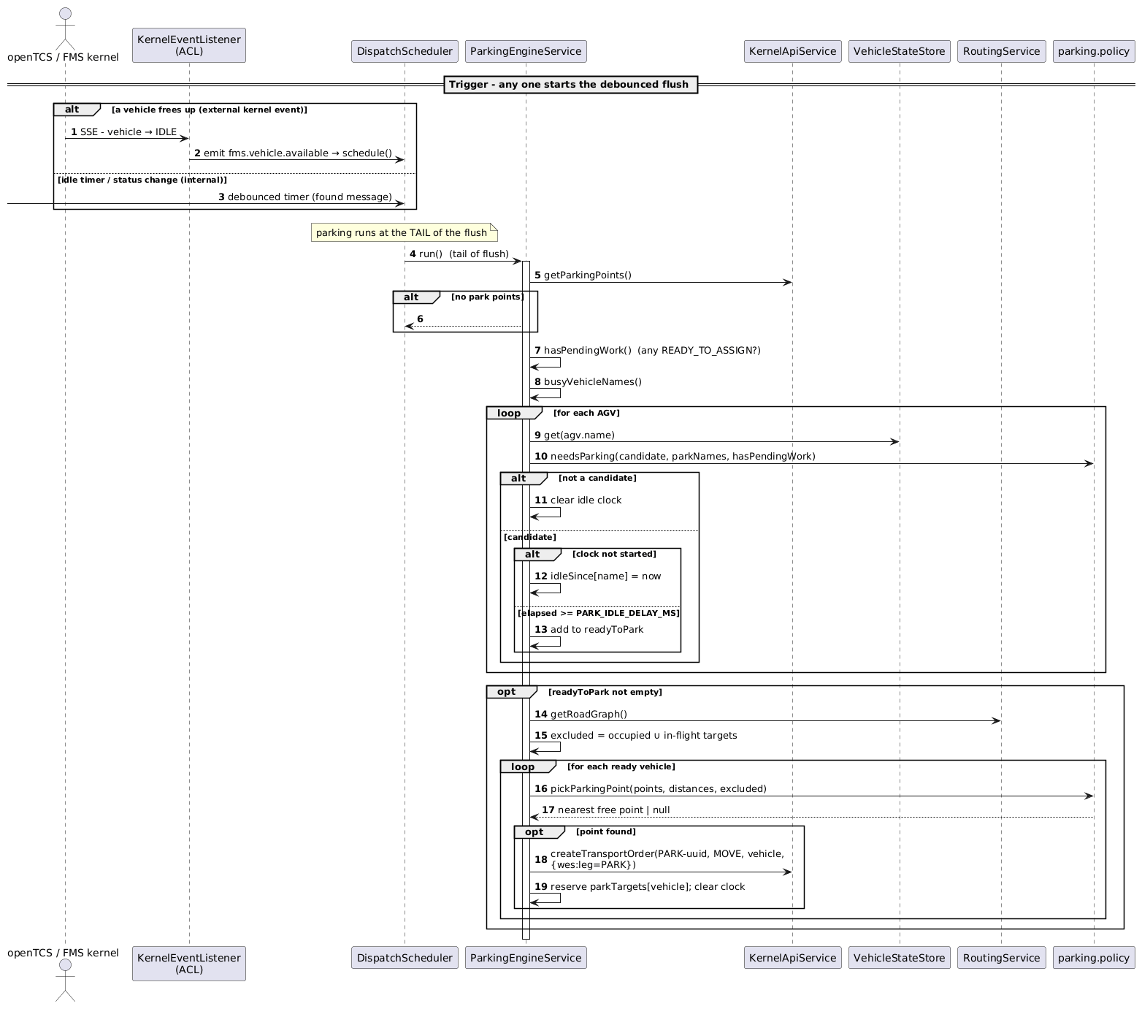

2.5 Idle Parking & Preemption
Correctness never depends on an in‑process event surviving. Two level‑triggered backstops re‑pull the kernel's authoritative state on a fixed heartbeat: the vehicle heartbeat in KernelEventListenerService (re‑seeds VehicleStateStore, re‑emits fms.vehicle.available) and LegReconcileService (first step of every flush) which re‑confirms each live task's expected leg and re‑fires fms.transport-order.finished (FINISHED) or fails the task (FAILED/UNROUTABLE).

2.5.1 Class Diagram
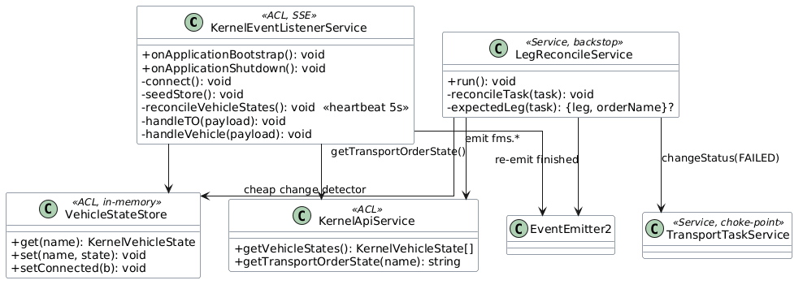

2.5.2 Sequence Diagram - Leg reconcile heals a lost "TO FINISHED"
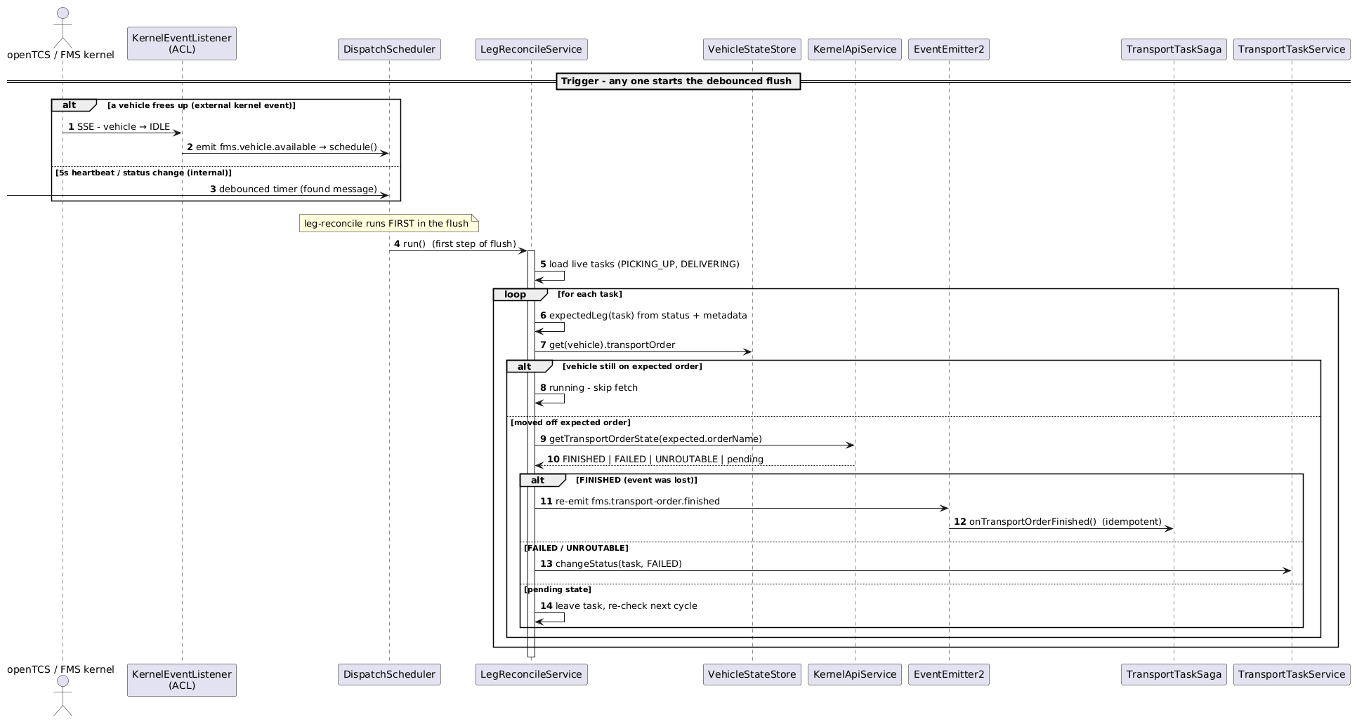

2.6 Dispatch Policy Administration
Admins tune dispatch behaviour through the dispatch_policies table via a guarded REST resource. The single‑active invariant (one active policy at a time) is enforced by an activate transaction plus a partial‑unique index; the assignment engine re‑reads the active weights on every flush, so a change takes effect on the next cycle with no restart.

2.6.1 Class Diagram
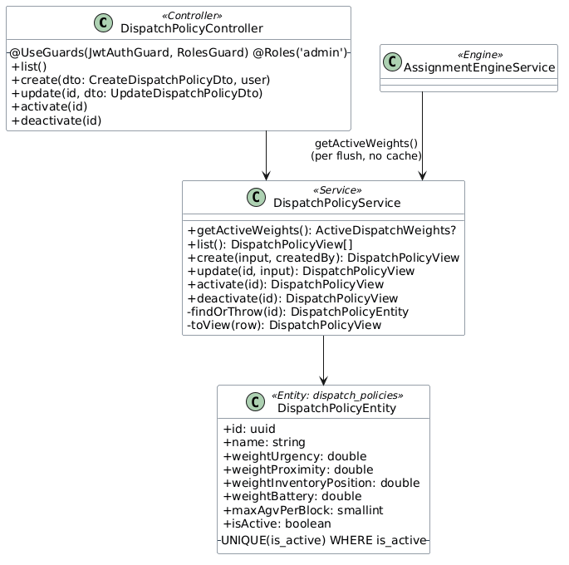

2.6.2 Sequence Diagram - Activate a policy (takes effect next flush)
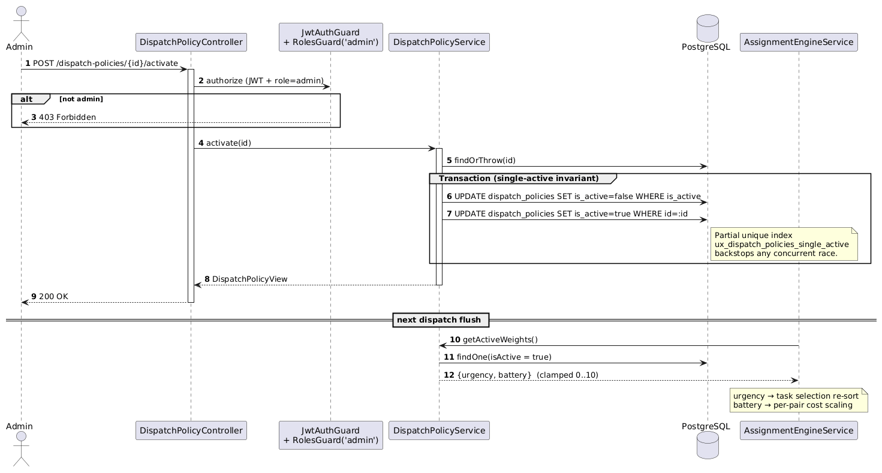

2.7 In‑Kernel MAPF Coordination
Once WES has assigned a task and pushed a location‑only transport order with intendedVehicle, the FMS kernel (customised openTCS 7.3, project opentcs-integration-FMS) performs the multi‑AGV work: a rolling‑horizon MAPF solve (RHCR + LaCAM*) computes a coordinated, deadlock‑aware plan for the whole fleet, and that plan drives both the routes vehicles receive and the order in which the scheduler grants point allocations. This is "Architecture C": MAPF is the fleet's routing brain, hooked at the Dispatcher (the only place with global fleet state), served through the Router, and enforced as ordering by a cooperating Scheduler.Module - openTCS's own collision‑freedom is kept, MAPF only adds precedence.

2.7.1 Class Diagram

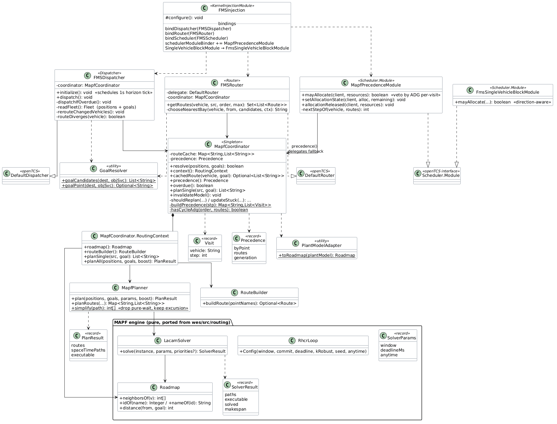

2.7.2 Sequence Diagram - Fleet‑wide MAPF dispatch cycle

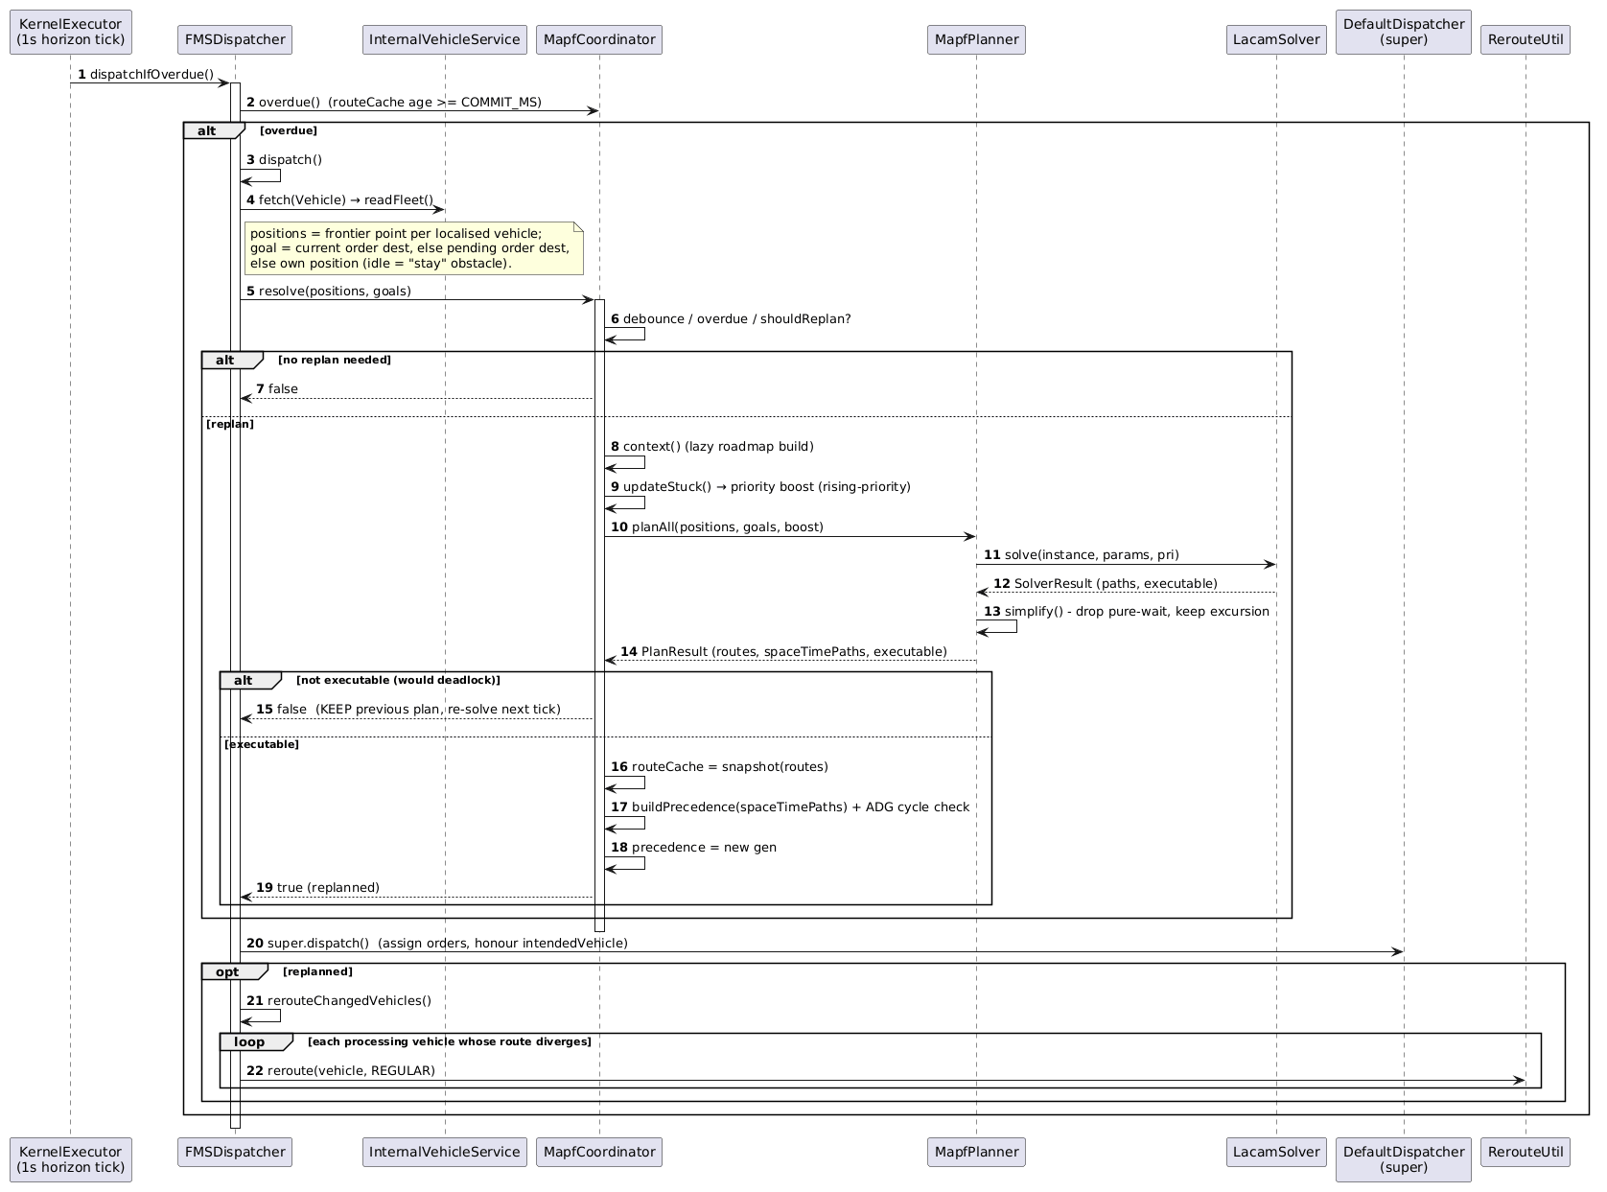

2.7.3 Sequence Diagram - Coordinated route service
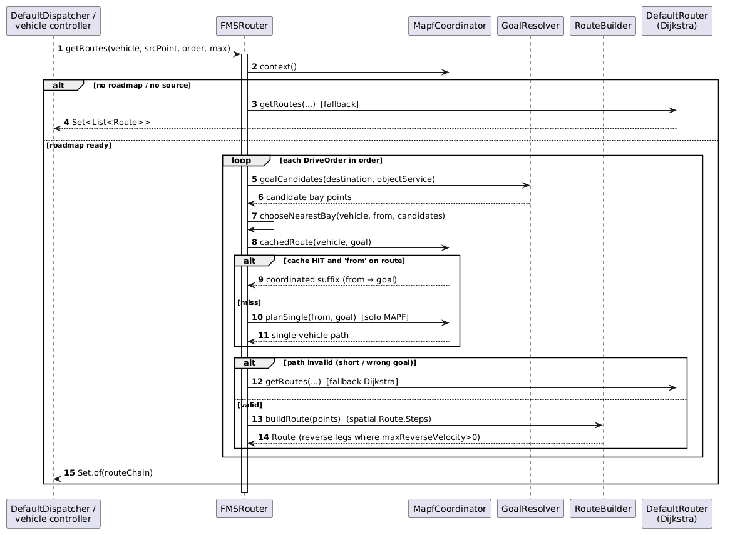

2.7.4 Sequence Diagram - Precedence‑ordered allocation
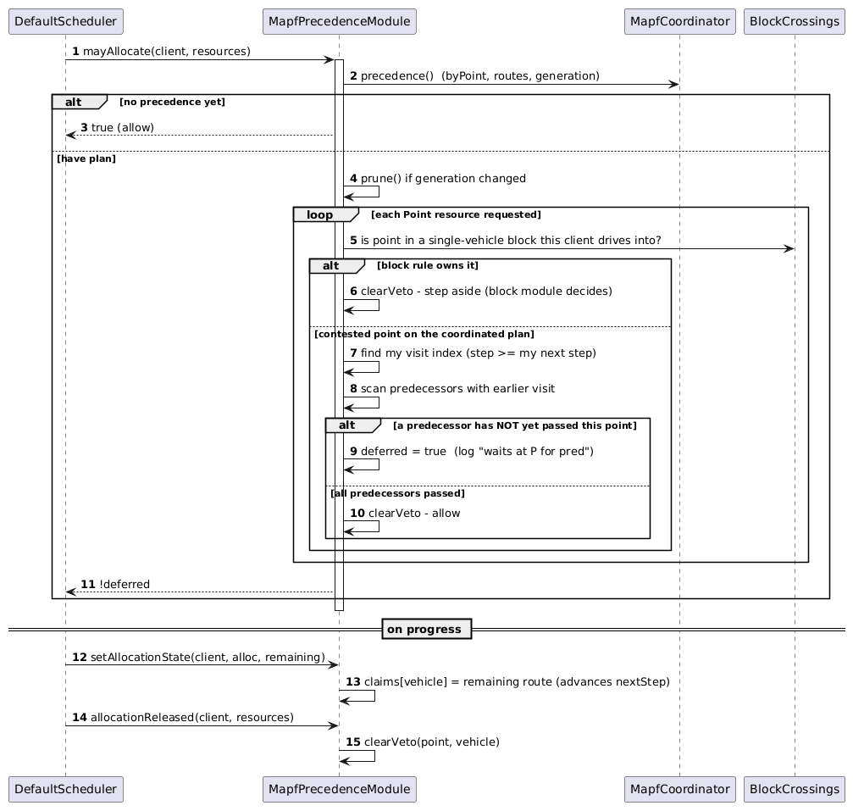

3. Class Specifications
This section specifies the principal classes of the SWES dispatch design shown in the Section 2 diagrams, grouped by package. For each class it lists the salient attributes and the public operations (private helpers are omitted unless they carry design intent). Visibility follows the source: public (+), private (-). Pure-domain modules expose module-level functions rather than instance methods; these are listed under Methods / Operations as static.

3.1 cargo (Business / Dispatch Orchestration)
The core domain package. It owns the transport-task lifecycle, the dispatch flush cycle and the four engines (release, assignment, saga, parking), the row-dependency anti-congestion rule and the weighted / lookahead matching. Everything under domain/ is framework-free and unit-testable without a DB or the kernel.

3.1.1 TransportTaskService
<<Service - single write choke point>>
The only writer of TransportTaskEntity.status. Validates each transition against the state machine, persists it, writes the append-only audit row, and emits the domain event - in exactly one place.
No | Name | Description
Attributes
1 | logger | Visibility: private  Type: Logger  Purpose: Class logger.
2 | taskRepo | Visibility: private  Type: Repository<TransportTaskEntity>  Purpose: Transport-request persistence.
3 | transitionRepo | Visibility: private  Type: Repository<TaskStatusTransitionEntity>  Purpose: Append-only audit log.
4 | eventEmitter | Visibility: private  Type: EventEmitter2  Purpose: In-process event bus.
Methods / Operations
1 | publishCreated | Visibility: public  Return: void  Purpose: Records the birth row (from=null) and emits transport-task.created after the task is persisted.  Parameters:  - task: TransportTaskEntity, the newly created task
2 | changeStatus | Visibility: public  Return: Promise<TransportTaskEntity>  Purpose: Validate -> persist -> audit -> emit status-changed (plus completed/failed on terminal states). The single transition path.  Parameters:  - task: TransportTaskEntity, the task to move  - to: TaskStatus, the target status  - log?: StatusChangeLog, trigger/reason/vehicle/context for the audit row
3 | recordTransition | Visibility: private  Return: Promise<void>  Purpose: Insert one task_status_transitions row; never throws into the dispatch path.  Parameters:  - task, from, to, log (see above)

3.1.2 TransportTaskStateMachine
<<pure / static - domain/transport-task.state-machine.ts>>
The single source of truth for the task lifecycle. Holds the transition table and is the only code that assigns task.status.
No | Name | Description
Attributes
1 | TRANSITIONS | Visibility: private  Type: Record<TaskStatus, TaskStatus[]>  Purpose: The legal-move table (source of truth).
Methods / Operations
1 | canTransition | Visibility: public (static)  Return: boolean  Purpose: True if from->to is a legal move.  Parameters:  - from: TaskStatus  - to: TaskStatus
2 | isCancellable | Visibility: public (static)  Return: boolean  Purpose: True if the status may transition to CANCELLED.  Parameters:  - status: TaskStatus
3 | transition | Visibility: public (static)  Return: void  Purpose: Sets task.status=to if legal; throws InvalidTransportTaskTransitionError otherwise. The ONLY assignment of task.status.  Parameters:  - task: TransportTaskEntity  - to: TaskStatus

3.1.3 DispatchSchedulerService
<<Service - orchestration backbone>>
The single debounced, single-flight entry point for every dispatch decision. All triggers collapse into one flush() that runs the four engines in a fixed order: leg-reconcile -> release -> assign -> park.
No | Name | Description
Attributes
1 | timer | Visibility: private  Type: Timeout | null  Purpose: Debounce timer handle.
2 | isFlushing | Visibility: private  Type: boolean  Purpose: Single-flight guard - only one cycle runs at a time.
3 | rerunWanted | Visibility: private  Type: boolean  Purpose: A trigger arrived mid-flush; re-run once after.
Methods / Operations
1 | onApplicationBootstrap | Visibility: public  Return: void  Purpose: Schedules one flush on startup so tasks left mid-lifecycle are re-evaluated.
2 | onDispatchTrigger | Visibility: public  Return: void  Purpose: @OnEvent(created / status-changed / vehicle.available) - debounced schedule().  Parameters:  - event: unknown, the triggering domain event
3 | schedule | Visibility: public  Return: void  Purpose: (Re)arm the 1.5 s debounce timer; coalesces a burst into one flush.
4 | flush | Visibility: private  Return: Promise<void>  Purpose: Run leg-reconcile -> release -> assign -> park under the single-flight guard.

3.1.4 ReleaseEngineService
<<Engine>>
Applies the pickup row-dependency rule (WF-02) on every at-source task: pass -> READY_TO_ASSIGN, fail -> BLOCKED, and gracefully preempts an in-flight pickup when an outer same-lane cargo appears.
No | Name | Description
Attributes
1 | logger | Visibility: private  Type: Logger  Purpose: Class logger.
Methods / Operations
1 | run | Visibility: public  Return: Promise<void>  Purpose: Evaluate every at-source task and block / unblock / preempt accordingly.
2 | block | Visibility: private  Return: Promise<void>  Purpose: Move CREATED|READY to BLOCKED, or preempt a PICKING_UP task.  Parameters:  - task: TransportTaskEntity  - reason: string | null
3 | unblock | Visibility: private  Return: Promise<void>  Purpose: Promote a freed CREATED|BLOCKED task back to READY_TO_ASSIGN.  Parameters:  - task: TransportTaskEntity
4 | preempt | Visibility: private  Return: Promise<void>  Purpose: Withdraw the pickup order (graceful) and re-block a task overtaken by an outer cargo.  Parameters:  - task: TransportTaskEntity  - reason: string | null

3.1.5 PickupDependencyService
<<Service>>
Decides which pickup tasks are blocked by the 'an AGV cannot drive through a row' rule. Ranks a zone's slots (lane/depth) via ZoneGeometryService and applies the pure pickup-dependency policy per lane. Also supplies the blocking-count urgency signal.
No | Name | Description
Attributes
1 | taskRepo / cargoRepo / zoneRepo | Visibility: private  Type: Repository<...>  Purpose: Task, cargo and zone persistence.
2 | zoneGeometry | Visibility: private  Type: ZoneGeometryService  Purpose: Computes lane/depth axes for a zone's members.
Methods / Operations
1 | evaluate | Visibility: public  Return: Promise<PickupDecision[]>  Purpose: Decision (blocked, reason) for every at-source task.
2 | blockingCounts | Visibility: public  Return: Promise<Map<string,number>>  Purpose: Per task: how many same-lane pickups it stands in front of (the urgency signal).
3 | isBlocked | Visibility: public  Return: Promise<boolean>  Purpose: Re-check a single task right before assignment (closes the release->assign race).  Parameters:  - task: TransportTaskEntity
4 | decide | Visibility: private  Return: Promise<PickupDecision[]>  Purpose: Core per-lane ranking + findBlocker over a task set.  Parameters:  - tasks: TransportTaskEntity[]

3.1.6 AssignmentEngineService
<<Engine>>
Turns READY_TO_ASSIGN tasks into PICKING_UP by solving a global minimum-cost matching (Hungarian, with a greedy counterfactual) over a task x vehicle cost matrix. Adds urgency selection, a battery term, and lookahead (soon-free vehicles join the matrix but are never dispatched; their task is reserved).
No | Name | Description
Attributes
1 | matcher | Visibility: private  Type: DispatchMatcher  Purpose: 'hungarian' (default) or 'greedy' (DISPATCH_MATCHER).
2 | lookaheadEnabled / lookaheadHops / lookaheadMaxAgeMs | Visibility: private  Type: boolean / number  Purpose: Lookahead gate and horizons.
3 | reservedSince | Visibility: private  Type: Map<string,number>  Purpose: Task -> epoch when it was first passed over for a soon-free vehicle (anti-starvation clock).
Methods / Operations
1 | run | Visibility: public  Return: Promise<void>  Purpose: Select -> build candidates (free + soon-free) -> Hungarian & greedy plans -> dispatch free winners, reserve soon-free winners.
2 | prioritise | Visibility: private  Return: Promise<TransportTaskEntity[]>  Purpose: Re-sort tasks by selectionScore(age, blocking) when the active policy sets urgency>0.  Parameters:  - tasks: TransportTaskEntity[]  - urgencyWeight: number
3 | computeLookahead | Visibility: private  Return: Promise<Map<string,VehicleLookahead>>  Purpose: For DELIVERING vehicles within the hop horizon, compute their finish position and remaining release distance.  Parameters:  - busyTasks, distancesTo, hopsTo
4 | buildCandidates | Visibility: private  Return: Promise<VehicleCandidate[]>  Purpose: Join AgvEntity registry with live VehicleStateStore telemetry + lookahead.  Parameters:  - busyTasks, lookaheadByVehicle
5 | assign | Visibility: private  Return: Promise<boolean>  Purpose: Preempt any park order, create TO1 (PICK_UP), then changeStatus to PICKING_UP with the measurement/counterfactual context.  Parameters:  - task, cargo, vehicleName, distanceToSource, parkOrderName, measurement

3.1.7 TransportTaskSaga
<<Saga / Process Manager>>
Drives each task through its three openTCS orders reacting to fms.transport-order.finished: TO1 (PICK_UP) -> TO2 (approach NOP) -> TO3 (DROP_OFF). Commits the concrete drop-off slot late, at the TO2 barrier, under a per-zone lock.
No | Name | Description
Attributes
1 | processing | Visibility: private  Type: Set<string>  Purpose: Single-flight per task id - the same finished event arrives from SSE and the reconcile backstop.
Methods / Operations
1 | onTransportOrderFinished | Visibility: public  Return: Promise<void>  Purpose: @OnEvent - route the finished order by its leg + task id (single-flight guarded).  Parameters:  - event: FmsTransportOrderFinishedEvent
2 | onPickupFinished | Visibility: private  Return: Promise<void>  Purpose: Pick an approach point, create TO2, move task to DELIVERING.  Parameters:  - taskId: string
3 | onApproachFinished | Visibility: private  Return: Promise<void>  Purpose: At the TO2 barrier: commit the drop-off slot, create TO3.  Parameters:  - taskId: string
4 | onDropOffFinished | Visibility: private  Return: Promise<void>  Purpose: Move task to DELIVERY_COMPLETED and cargo to DELIVERED.  Parameters:  - taskId: string
5 | commitDropoffSlot | Visibility: private  Return: Promise<string|null>  Purpose: Atomically pick+reserve a concrete slot under a per-zone advisory lock (idempotent).  Parameters:  - cargo: CargoEntity

3.1.8 DispatchPolicyService
<<Service>>
CRUD for the dispatch_policies weights and the single-active invariant. The assignment engine reads the active weights once per flush (no cross-process cache).
No | Name | Description
Attributes
1 | repo | Visibility: private  Type: Repository<DispatchPolicyEntity>  Purpose: Policy persistence.
Methods / Operations
1 | getActiveWeights | Visibility: public  Return: Promise<ActiveDispatchWeights|null>  Purpose: Clamped {urgency, battery} of the active policy, re-read each flush; null -> pure-distance FIFO fast path.
2 | list | Visibility: public  Return: Promise<DispatchPolicyView[]>  Purpose: All policies.
3 | create | Visibility: public  Return: Promise<DispatchPolicyView>  Purpose: Create a policy (inactive by default).  Parameters:  - input & {name}  - createdBy: string|null
4 | update | Visibility: public  Return: Promise<DispatchPolicyView>  Purpose: Patch a policy's weights / name.  Parameters:  - id: string  - input: DispatchPolicyInput
5 | activate | Visibility: public  Return: Promise<DispatchPolicyView>  Purpose: Deactivate-all-then-activate in one transaction; the partial-unique index backstops races.  Parameters:  - id: string
6 | deactivate | Visibility: public  Return: Promise<DispatchPolicyView>  Purpose: Deactivate one policy.  Parameters:  - id: string

3.1.9 RoutingService
<<Service>>
Builds the directed road graph from the openTCS plant model and caches it (plus its reverse). Dijkstra-from-a-point on the reverse graph yields every point's driving distance TO that point - the vehicle->pickup cost the matcher needs.
No | Name | Description
Attributes
1 | cachedModel / cachedGraph / cachedReverseGraph | Visibility: private  Type: unknown / RoadGraph|null  Purpose: Model-keyed graph caches.
Methods / Operations
1 | getRoadGraph | Visibility: public  Return: Promise<RoadGraph|null>  Purpose: The directed graph; rebuilt only when the plant model changes.
2 | getReverseRoadGraph | Visibility: public  Return: Promise<RoadGraph|null>  Purpose: The same graph with every edge flipped.
3 | pointsOfLocations | Visibility: public  Return: Promise<Map<string,string>>  Purpose: Resolve location names to their linked point names (used by lookahead).  Parameters:  - locationNames: string[]

3.1.10 ParkingEngineService
<<Engine>>
Runs at the tail of the flush. Sends a vehicle idle with no cargo work for PARK_IDLE_DELAY_MS to the nearest free park point; suppressed while any task waits, and a parking vehicle stays preemptible by the assignment engine.
No | Name | Description
Attributes
1 | idleSince | Visibility: private  Type: Map<string,number>  Purpose: Vehicle -> epoch it became a parking candidate (in-RAM; re-arms on restart).
2 | parkTargets | Visibility: private  Type: Map<string,{point,order}>  Purpose: In-flight point reservations so two vehicles never target one point.
Methods / Operations
1 | run | Visibility: public  Return: Promise<void>  Purpose: Find idle-elapsed candidates and issue PARK-<uuid> MOVE orders to distinct nearest points.
2 | createParkOrder | Visibility: private  Return: Promise<void>  Purpose: Create the park order (tagged wes:leg=PARK so it never enters the saga) and reserve the point.  Parameters:  - vehicleName: string  - pointName: string

3.1.11 LegReconcileService
<<Service - level-triggered backstop>>
First step of the flush. If a 'TO FINISHED' SSE frame was lost, recomputes each live task's expected leg and confirms it against the kernel: FINISHED -> re-fire the event; FAILED/UNROUTABLE -> fail the task. Never pulls the unbounded order list.
No | Name | Description
Attributes
1 | taskRepo / vehicleStore / kernelApi / transportTask / eventEmitter | Visibility: private  Type: ...  Purpose: Task repo, live telemetry, ACL, choke point, event bus.
Methods / Operations
1 | run | Visibility: public  Return: Promise<void>  Purpose: Reconcile every PICKING_UP / DELIVERING task.
2 | reconcileTask | Visibility: private  Return: Promise<void>  Purpose: Fetch the single expected order by name only when the vehicle has moved off it.  Parameters:  - task: TransportTaskEntity
3 | expectedLeg | Visibility: private  Return: {leg,orderName}|null  Purpose: Derive the leg the task is waiting on from its status + metadata.  Parameters:  - task: TransportTaskEntity

3.1.12 DeliverySlotEngine
<<Engine>>
Late-binds the concrete drop-off slot at the TO2 barrier. Fills slots farthest from the zone exit first (cascade) so a later drop never physically blocks an earlier one on a one-way lane.
No | Name | Description
Attributes
1 | kernelApi / cargoRepo | Visibility: private  Type: ...  Purpose: Plant model reads, occupancy reads.
Methods / Operations
1 | findSlot | Visibility: public  Return: Promise<string|null>  Purpose: Pick the next fillable member slot by farthest-from-exit cascade; null when full/misconfigured.  Parameters:  - zone: ZoneEntity
2 | hasAvailableSlot | Visibility: public  Return: Promise<boolean>  Purpose: Whether any slot is currently fillable.  Parameters:  - zone: ZoneEntity

3.2 opentcs (Anti-Corruption Layer)
The only package that talks to the openTCS kernel. It wraps the kernel Service Web API (REST commands + SSE telemetry), caches live vehicle state in memory, and translates SSE frames into fms.* domain events. openTCS types never leak into the business modules; the package exports only KernelApiService and VehicleStateStore.

3.2.1 KernelApiService
<<ACL - REST client>>
All axios/HTTP calls to the openTCS kernel. Business modules go through this class; openTCS error types never propagate outward.
No | Name | Description
Attributes
1 | baseUrl | Visibility: private  Type: string  Purpose: OPENTCS_KERNEL_URL (default http://localhost:55200).
2 | plant-model cache | Visibility: private  Type: object|null  Purpose: Cached plant model, invalidated on reconnect/topology change.
Methods / Operations
1 | createTransportOrder | Visibility: public  Return: Promise<void>  Purpose: POST /v1/transportOrders/{name}: create an order with drops, intendedVehicle and wes:* properties.  Parameters:  - name, destinations, vehicleName, properties
2 | withdrawTransportOrder | Visibility: public  Return: Promise<void>  Purpose: POST /v1/transportOrders/{name}/withdrawal (graceful or immediate).  Parameters:  - name: string  - immediate=true
3 | getPlantModel | Visibility: public  Return: Promise<object|null>  Purpose: GET /v1/plantModel (cached).
4 | getVehicleStates | Visibility: public  Return: Promise<KernelVehicleState[]>  Purpose: GET /v1/vehicles snapshot.
5 | getTransportOrderState | Visibility: public  Return: Promise<string|null>  Purpose: Fetch one order's state by name (leg reconcile).  Parameters:  - name: string
6 | computeRoutes | Visibility: public  Return: Promise<KernelRoute[]>  Purpose: routeComputationQuery: costs from a vehicle to candidate points.  Parameters:  - vehicleName, points
7 | getParkingPoints / findPickupLocationForPoint / findPointForLocation | Visibility: public  Return: Promise<...>  Purpose: Plant-model topology lookups used by parking / cargo intake / read model.

3.2.2 KernelEventListenerService
<<ACL - SSE listener + heartbeat>>
Subscribes to the kernel SSE stream and translates telemetry into fms.* events. A level-triggered heartbeat (DISPATCH_HEARTBEAT_MS) re-pulls the authoritative vehicle snapshot so a lost frame self-heals within one tick.
No | Name | Description
Attributes
1 | heartbeatTimer / reconnectTimer | Visibility: private  Type: Timer  Purpose: Heartbeat and reconnect handles.
2 | baseUrl | Visibility: private  Type: string  Purpose: Kernel base URL.
Methods / Operations
1 | onApplicationBootstrap | Visibility: public  Return: void  Purpose: Open the SSE connection and start the heartbeat.
2 | handleTO | Visibility: private  Return: void  Purpose: On a FINISHED order carrying wes:taskId + wes:leg, emit fms.transport-order.finished.  Parameters:  - payload
3 | handleVehicle | Visibility: private  Return: void  Purpose: Update the store; emit fms.vehicle.available on any change landing on an available state.  Parameters:  - payload
4 | reconcileVehicleStates | Visibility: private  Return: Promise<void>  Purpose: Heartbeat: re-pull GET /v1/vehicles into the store and poke the dispatch cycle.

3.2.3 VehicleStateStore
<<ACL - in-memory cache>>
The live vehicle-telemetry cache. The dispatch engines read current position, procState, energyLevel and the vehicle's current transportOrder from here.
No | Name | Description
Attributes
1 | states | Visibility: private  Type: Map<string,KernelVehicleState>  Purpose: Latest known state per vehicle.
2 | connected | Visibility: private  Type: boolean  Purpose: Whether the SSE stream is up.
Methods / Operations
1 | get | Visibility: public  Return: KernelVehicleState|undefined  Purpose: Latest state for a vehicle name.  Parameters:  - name: string
2 | set | Visibility: public  Return: void  Purpose: Upsert a vehicle's state.  Parameters:  - name: string  - state: KernelVehicleState
3 | setConnected | Visibility: public  Return: void  Purpose: Record SSE connection status.  Parameters:  - connected: boolean

3.3 opentcs-integration-FMS (openTCS Kernel - MAPF)
The customised openTCS 7.3 kernel (Java). Architecture C embeds multi-AGV MAPF (RHCR + LaCAM*) as the fleet's routing brain, hooked at the Dispatcher, served through the Router, and enforced as precedence by a cooperating Scheduler.Module. openTCS's own collision-freedom (DefaultScheduler) is kept; MAPF only adds ordering.

3.3.1 FMSDispatcher
<<Dispatcher - extends DefaultDispatcher>>
Drives the fleet-wide MAPF cadence. Each cycle it reads every localised vehicle's position and goal, runs a joint solve via MapfCoordinator, delegates assignment to DefaultDispatcher (honouring WES's intendedVehicle), then reroutes vehicles whose coordinated route changed.
No | Name | Description
Attributes
1 | coordinator | Visibility: private  Type: MapfCoordinator  Purpose: Shared roadmap + solver + route cache + precedence.
2 | HORIZON_TICK_MS | Visibility: private  Type: long  Purpose: 1000 - the periodic solve/commit cadence.
Methods / Operations
1 | dispatch | Visibility: public  Return: void  Purpose: readFleet -> coordinator.resolve -> super.dispatch -> reroute changed vehicles.
2 | readFleet | Visibility: private  Return: Fleet  Purpose: Collect frontier positions and current/pending goals of all localised vehicles.
3 | rerouteChangedVehicles | Visibility: private  Return: void  Purpose: Reroute (REGULAR) each processing vehicle whose committed route diverges from the fresh plan.
4 | dispatchIfOverdue | Visibility: private  Return: void  Purpose: Timer tick: re-solve when the cached plan is older than the commit window.

3.3.2 FMSRouter
<<Router - implements Router>>
Serves coordinated routes from the MapfCoordinator cache (cutting the suffix from the vehicle's current point to its goal). A cache miss falls back to a solo MAPF plan; any invalidity falls back to the stock Dijkstra DefaultRouter.
No | Name | Description
Attributes
1 | delegate | Visibility: private  Type: DefaultRouter  Purpose: Stock router used as fallback.
2 | coordinator | Visibility: private  Type: MapfCoordinator  Purpose: Route cache + roadmap.
Methods / Operations
1 | getRoutes | Visibility: public  Return: Set<List<Route>>  Purpose: Build the drive-order route chain from the coordinated cache / solo MAPF / Dijkstra fallback.  Parameters:  - vehicle, sourcePoint, order, maxRoutesPerDriveOrder
2 | chooseNearestBay | Visibility: private  Return: String  Purpose: Pick the reachable goal bay for a drive-order destination.  Parameters:  - vehicle, from, candidates, ctx

3.3.3 MapfCoordinator
<<Singleton>>
The routing brain: builds the roadmap from the plant model, runs the joint RHCR/LaCAM* solve, caches per-vehicle routes and derives the per-visit precedence (ADG). Keeps the previous plan when the solver returns a non-executable one.
No | Name | Description
Attributes
1 | routeCache | Visibility: private  Type: Map<String,List<String>>  Purpose: Coordinated route per vehicle.
2 | precedence | Visibility: private  Type: Precedence  Purpose: byPoint visit order + routes + generation (drives the Scheduler veto).
3 | resolving / forceReplan | Visibility: private  Type: AtomicBoolean  Purpose: Re-entrancy and forced-replan guards.
Methods / Operations
1 | resolve | Visibility: public  Return: boolean  Purpose: Debounce/overdue/should-replan gate, then joint solve; commit routes + precedence only if executable. Returns whether it replanned.  Parameters:  - positions: Map<String,String>  - goals: Map<String,String>
2 | cachedRoute | Visibility: public  Return: Optional<List<String>>  Purpose: The cached coordinated route for (vehicle, goal), if the goal matches.  Parameters:  - vehicle, goal
3 | precedence | Visibility: public  Return: Precedence  Purpose: Current precedence snapshot (read by the Scheduler module).
4 | planSingle | Visibility: public  Return: List<String>  Purpose: Solo single-vehicle MAPF path (router miss).  Parameters:  - source, goal
5 | overdue | Visibility: public  Return: boolean  Purpose: Whether the cached plan is past the commit window.

3.3.4 MapfPlanner
<<pure planner>>
Turns one MAPF solve into per-vehicle spatial routes. Rule #1: only a pure-wait is inexpressible as a Route.Step (no time axis) - simplify() drops pure-waits but KEEPS back-up-to-yield excursions; timing is enforced later by allocation denial.
No | Name | Description
Attributes
1 | roadmap | Visibility: private  Type: Roadmap  Purpose: Integer-indexed graph.
2 | solver | Visibility: private  Type: LacamSolver  Purpose: Anytime LaCAM* solver.
Methods / Operations
1 | plan | Visibility: public  Return: PlanResult  Purpose: Joint solve -> {routes (pure-waits dropped), spaceTimePaths (raw), executable}.  Parameters:  - positions, goals, params, priorityBoost
2 | simplify | Visibility: public (static)  Return: int[]  Purpose: Collapse consecutive duplicates (drop pure-wait, keep excursion).  Parameters:  - path: int[]

3.3.5 MapfPrecedenceModule
<<Scheduler.Module>>
Realises the MAPF wait/ordering as allocation denial. On each allocation it vetoes a point when a same-point predecessor in the coordinated plan (ADG per-visit) has not yet passed; collision-freedom stays with DefaultScheduler.
No | Name | Description
Attributes
1 | claims | Visibility: private  Type: Map<String,List<String>>  Purpose: Each vehicle's remaining claimed route (advances the next-step cursor).
2 | generation | Visibility: private  Type: long  Purpose: Precedence generation last pruned against.
Methods / Operations
1 | mayAllocate | Visibility: public  Return: boolean  Purpose: Allow unless a not-yet-passed predecessor owns an earlier visit of a contested point.  Parameters:  - client: Scheduler.Client  - resources: Set<TCSResource>
2 | setAllocationState | Visibility: public  Return: void  Purpose: Track a client's remaining route (drives nextStepOf).  Parameters:  - client, alloc, remaining
3 | allocationReleased | Visibility: public  Return: void  Purpose: Clear the veto for a released point.  Parameters:  - client, resources

4. Other Design Specifications
This section records the cross-cutting design decisions that the class and sequence diagrams reference: data design beyond the ER model, the key algorithms, the openTCS integration boundary, the concurrency / consistency model, and the runtime configuration.

4.1 Data Design
Beyond the 16 tables of the ER model (Section 1.3), three dispatch-specific structures carry design intent:
• dispatch_policies - the tunable weights (weight_urgency, weight_proximity, weight_inventory_position, weight_battery, max_agv_per_block) with a single-active invariant enforced by the partial unique index ux_dispatch_policies_single_active ON (is_active) WHERE is_active. Zero active rows => the engine takes the pure-distance FIFO fast path.
• task_status_transitions - an append-only audit row per status change (birth row has from_status=null). Its jsonb context also stores the offline-evaluation DispatchMeasurement: the matcher used, batch size, the counterfactual vehicle + distance (the plan the OTHER matcher would have produced), and lookahead / reserved counts.
• Late-bound drop-off slot - a cargo reserves only a SEAT at intake (destination_zone_id set, destination_location_name null). The concrete slot is committed at the TO2 barrier, so occupancy reflects the vehicle's physical arrival and fill order stays correct on one-way lanes.
The map topology (points, paths, locations) is intentionally NOT stored in the WES database - it lives in the openTCS plant model and is read through the ACL.

4.2 Algorithms
Assignment (cargo). A batch of the FIFO-head tasks (N = number of matchable vehicles) is matched to vehicles by the Hungarian minimum-cost algorithm over a cost matrix. A reachable pair costs the reverse-graph Dijkstra distance vehicle->pickup, optionally scaled by battery: cost = distance x (1 + w_batt x (1 - battery/100)). Unknown pairs get a finite sentinel larger than any full batch; a graph-confirmed unreachable pair gets a second, larger sentinel and is dropped - so the solver first maximises feasible cardinality, then minimises unknown pairs and weighted cost. Task selection order is FIFO, or re-sorted by selectionScore(age, blocking-count) when the active policy sets urgency>0.
Lookahead. A vehicle still DELIVERING but within DISPATCH_LOOKAHEAD_HOPS of its drop-off point joins the matrix as a soon-free candidate at its finish position, its cost padded by the remaining release distance. If it wins a task the task is RESERVED (kept READY_TO_ASSIGN, never dispatched to a busy vehicle) so a slightly-closer soon-free vehicle is not beaten by a far idle one - but a free vehicle is never left idle. A task reserved longer than DISPATCH_LOOKAHEAD_MAX_AGE_MS is barred from soon-free vehicles (freeVehiclesOnly) - anti-starvation. Both a Hungarian and a greedy plan are computed every cycle; the configured one is applied and the other recorded as a counterfactual for offline A/B evaluation.
Row dependency (WF-02). Within one lane a cargo can be picked only once every cargo closer to the aisle has left its source point. The pure rule ranks candidates by (laneKey, depthKey) and blocks a task while any same-lane candidate has a smaller depth.
Delivery-slot fill. Slots are filled farthest-from-exit first via a cascade over hops-to-exit columns, so a later drop never sits between an earlier one and the exit - which would physically block the vehicle even though openTCS routing ignores parked cargo.
In-kernel MAPF (FMS). A rolling-horizon (RHCR) loop replans from real vehicle positions each window and solves the joint problem with an anytime, validity-aware LaCAM* (swap on, rising-priority for liveness). The solution is a space-time plan; only a pure-wait is inexpressible as an openTCS Route.Step, so the planner drops pure-waits but keeps excursions. Waiting/ordering is realised as ALLOCATION DENIAL via an ADG per-visit precedence in a Scheduler.Module, never as extra waypoints. A plan is committed only if the solver proves it executable (materialises collision-free); otherwise the previous plan is kept and re-solved next tick.

4.3 System Integration (openTCS boundary)
SWES dispatching takes over the kernel's default dispatching: WES chooses the vehicle (business dispatch) and pushes a location-only transport order with intendedVehicle already set; the kernel performs the coordinated routing and precedence-ordered allocation. In openTCS vocabulary the WES backend is a kernel client of the Service Web API (the same class as Operations Desk), i.e. an external system actor; the in-kernel MAPF code is compiled INSIDE the kernel and is not an actor.
• Commands (WES -> kernel), REST: createTransportOrder, withdrawal, /dispatcher/trigger, plant-model reads, GET /v1/vehicles, PUT /v1/kernel/state - all through KernelApiService.
• Telemetry (kernel -> WES), SSE (/v1/sse): vehicle and transport-order frames, translated to fms.vehicle.available and fms.transport-order.finished by KernelEventListenerService.
• Leg correlation: each order carries wes:taskId + wes:leg properties (not the opaque order name), so the saga routes a finished order to the right task and leg.
• Resilience: SSE is the low-latency path but correctness never depends on a frame - two level-triggered backstops (vehicle heartbeat, LegReconcile) re-pull authoritative kernel state on a fixed heartbeat and re-emit lost events idempotently.

4.4 Concurrency & Consistency
• Per-zone advisory lock (pg_advisory_xact_lock) serialises the seat-capacity check at intake and the concrete slot commit at the TO2 barrier, so concurrent requests cannot over-admit or double-assign a slot.
• Single-flight debounced flush: one dispatch cycle runs at a time; a trigger arriving mid-flush schedules exactly one re-run, so no work is dropped and no cycle overlaps.
• Saga single-flight per task id absorbs the duplicate finished event (SSE + reconcile), and every fms.* consumer is idempotent (the saga bails if the next leg already exists).
• The audit row is written in the same transaction as the status change; the single-active policy index backstops concurrent activations.
• Deployment is a single replica, so no cross-process lock is required; the active-policy weights are re-read each flush rather than cached across processes.

4.5 Runtime Configuration
Behaviour is tuned by environment variables / system properties with safe defaults (off or conservative), so the base pure-distance FIFO dispatch always holds:
Variable | Default | Effect
DISPATCH_MATCHER | hungarian | Active matcher (hungarian | greedy); the other is recorded as a counterfactual.
DISPATCH_LOOKAHEAD | on | Enable soon-free lookahead candidates (set 'off' to disable).
DISPATCH_LOOKAHEAD_HOPS | 30 | Max hops from a DELIVERING vehicle's drop-off point to qualify as soon-free.
DISPATCH_LOOKAHEAD_MAX_AGE_MS | 60000 | A task reserved longer than this is forced onto a free vehicle.
DISPATCH_DROPOFF_PENALTY_MM | 0 | Extra release-distance padding added to a soon-free vehicle's cost.
DISPATCH_AGE_HORIZON_MS | 600000 | Age normalisation horizon for the urgency selection score.
DISPATCH_BLOCK_MAX | 5 | Blocking-count normalisation cap for the urgency score.
DISPATCH_HEARTBEAT_MS | 5000 | Vehicle-state reconcile heartbeat period.
PARK_IDLE_DELAY_MS | 10000 | Idle time before a free vehicle is sent to park.
OPENTCS_KERNEL_URL | http://localhost:55200 | openTCS kernel base URL.
fms.mapf.anytime (JVM) | true | LaCAM* anytime mode in the kernel solver.
fms.mapf.commitMs (JVM) | 3500 | MAPF plan commit window (re-solve when older).

